Making the hidden states of a battery visible
A battery management system (BMS) needs to know what is happening inside a battery to operate it safely, efficiently and reliably. However, some of the most important battery properties—such as the state-of-charge (SOC) and the internal temperature—cannot be measured directly during normal operation.
Researchers within the Current Direct project have developed a new method to estimate these hidden battery states using signals that can be measured easily, such as current, voltage and surface temperature.
The approach combines an electrical model and a thermal model of the battery with an adaptive sliding mode observer. The observer continuously compares the measured battery behavior with the model and adjusts its operation according to the estimation error. This adaptive approach helps maintain accurate estimates when the model does not perfectly represent the real battery, for example because of measurement disturbances, parameter uncertainties or battery ageing.
The method was experimentally validated using a commercial 64 Ah lithium-ion pouch cell, including both fresh and aged cells and different operating conditions. The results showed less than 1% SOC estimation error for the fresh cell and less than 3% for the aged cell in the reported experiments. The method also showed good robustness when the initial battery state was deliberately set incorrectly.
By turning easily measured battery signals into continuous information about what is happening inside the cell, this work provides an important building block for more accurate and reliable battery management systems. Better knowledge of the battery’s internal state can ultimately support safer operation, improved performance and smarter use of batteries in applications such as those being developed within Current Direct.

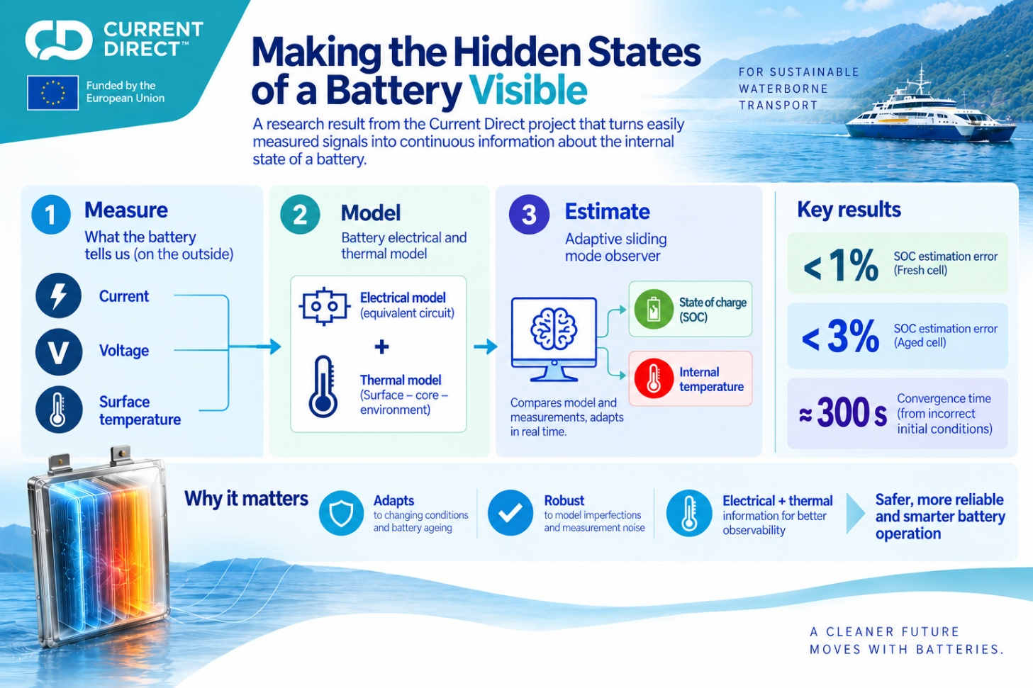

- https://doi.org/10.5281/zenodo.20158089

